Holy Name Catholic Church
2901 Fontenelle Boulevard
Omaha, NE 68104
(402) 451-6622
www.holynameomaha.org/

St. Philip Neri-Blessed Sacrament Parish
8200 N. 30th St.
Omaha, NE 68112
(402) 455-1289
www.saintphilipneriblessedsacrament.org/

Religious Education Registration Form
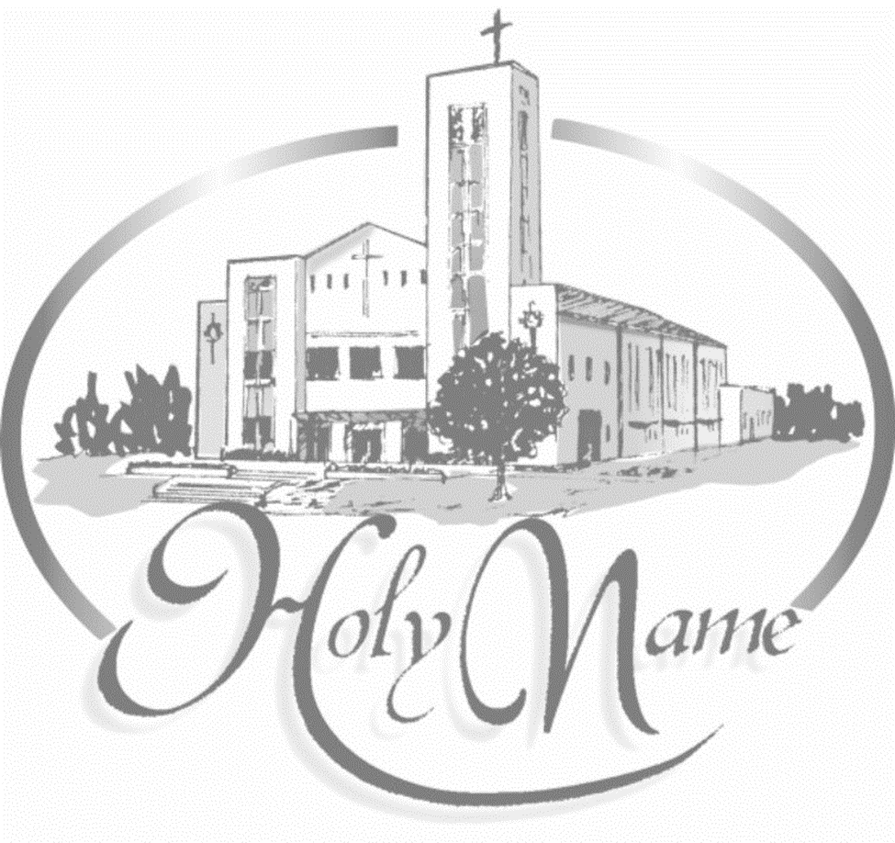

Please legibly print your responses and complete BOTH sides. Please make checks payable to Holy Name Church.
Registered Parishioners: $50 per child. Max of $150 for 3 children or more.

Registration date: ________________________________

Father’s Name___________________________________ Mother’s Name______________________________________ Mother’s Maiden Name_________________________________________________
Registered in Parish YES NO Please circle your parish: Holy Name St. Philip Neri-Blessed Sacrament
Children Live With___________________________________________________________________________________
Address____________________________________________________________________________________________
City/State/Zip Code__________________________________________________________________________________
Home Phone________________________ Mom Cell _______________________ Dad Cell ________________________
Your Best Email Address: _____________________________________________________________________________
In the event of an emergency, who else may be contacted? Name_____________________________________________ Phone # __________________________________ Relationship to family_________________________________________
Please list person or persons who will be dropping/picking up children other than parents:
Name: ___________________________________________ Phone #____________________________________
Students’ information
Students name | Grade | Date of Birth | Baptized | Received 1st communion | Childs preferred language | Sacraments  needed?

Special Needs: Do any of the kids have learning difficulties, allergies, physical or health needs/family circumstances? Please write the name of the child, the special needs of the child and any special care that they require
_________________________________________________________________________________________
_________________________________________________________________________________________
_________________________________________________________________________________________

Sometimes we take pictures in special events and classrooms, do we have permission to use your child’s photo in our parish or classroom posts?
Yes _________ Signature _____________________________________ No______________

PARENTS CONTRACT
I promise to fulfill my responsibility as a parent practicing the catholic faith with my kids. I understand that practicing the faith means assisting Sunday mass and the days of obligation and living my faint in accordance with the teachings of our Holy Church.
Parents name: ________________________________
Signature: ____________________________________________ Date: _____________________________________

-----------------------------------------------------------------OFFICE USE ONLY---------------------------------------------------------------------
Amount Paid $ | Check# | Date Paid: | Documents needed:  - Birth certificate  - Baptism certificate  - First Communion certificate  (needed for confirmation)  o Sponsors form

____________________________________________________________

