**Holy Name Catholic Church**

2901 Fontenelle Boulevard

Omaha, NE 68104

(402) 451-6622

[www.holynameomaha.org/](http://www.holynameomaha.org/)



**St. Philip Neri-Blessed Sacrament Parish**

8200 N. 30th St.

Omaha, NE 68112

(402) 455-1289

[www.saintphilipneriblessedsacrament.org/](http://www.saintphilipneriblessedsacrament.org/)

**Religious Education Registration Form**

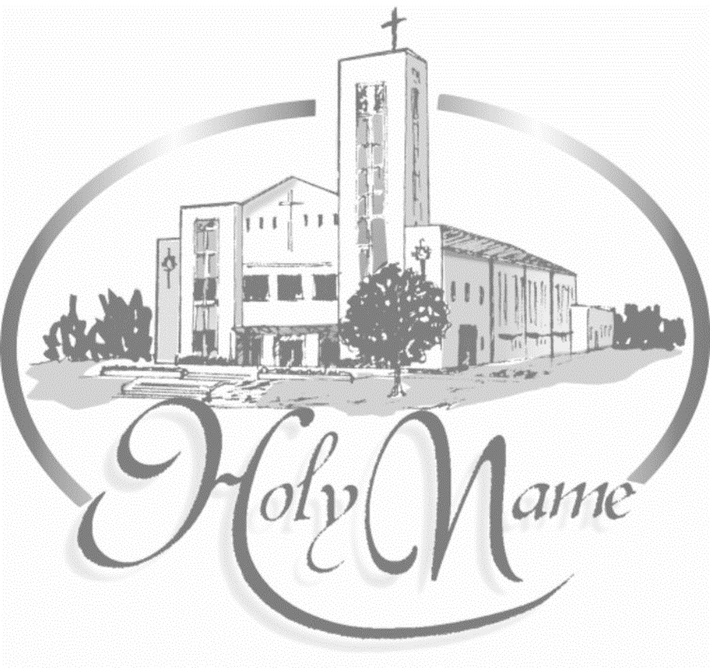

**Please legibly print your responses and complete BOTH sides. Please make checks payable to Holy Name Church.**

**Registered Parishioners:** $50 per child. Max of $150 for 3 children or more.

Registration date:________________________________

Father’s Name___________________________________ Mother’s Name______________________________________ Mother’s Maiden Name_________________________________________________

Registered in Parish YES NO Please circle your parish: Holy Name St. Philip Neri-Blessed Sacrament

Children Live With___________________________________________________________________________________

Address____________________________________________________________________________________________

City/State/Zip Code__________________________________________________________________________________

Home Phone________________________ Mom Cell _______________________ Dad Cell ________________________

Your Best Email Address: _____________________________________________________________________________

**In the event of an emergency, who else may be contacted?** Name_____________________________________________ Phone # __________________________________ Relationship to family_________________________________________

**Please list person or persons who will be dropping/picking up children other than parents:**   
Name: ___________________________________________ Phone #____________________________________

Students’ information

|  |  |  |  |  |  |  |
| --- | --- | --- | --- | --- | --- | --- |
| Students name | Grade | Date of Birth | Baptized | Received 1st communion | Childs preferred language | Sacraments needed? |
|  |  |  |  |  |  |  |
|  |  |  |  |  |  |  |
|  |  |  |  |  |  |  |
|  |  |  |  |  |  |  |

**Special Needs:** Do any of the kids have learning difficulties, allergies, physical or health needs/family circumstances? Please write the name of the child, the special needs of the child and any special care that they require

**_________________________________________________________________________________________**

_________________________________________________________________________________________

_________________________________________________________________________________________

Sometimes we take pictures in special events and classrooms, do we have permission to use your child’s photo in our parish or classroom posts?

Yes _________ Signature _____________________________________ No______________

**PARENTS CONTRACT**

**I promise to fulfill my responsibility as a parent practicing the catholic faith with my kids. I understand that practicing the faith means assisting Sunday mass and the days of obligation and living my faint in accordance with the teachings of our Holy Church.**

**Parents name: ________________________________**

**Signature: ____________________________________________ Date: _____________________________________**

**-----------------------------------------------------------------OFFICE USE ONLY---------------------------------------------------------------------**

|  |  |  |  |
| --- | --- | --- | --- |
| Amount Paid $ | Check# | Date Paid: | Documents needed:   * Birth certificate * Baptism certificate * First Communion certificate   (needed for confirmation)  o Sponsors form |

____________________________________________________________